**Data Base Systems I**

**CSC322**

**Initial Project Report**

**Title: Payroll Management System using MySQL Database**



|  |  |
| --- | --- |
| **Name:** | *Manahil Fayyaz, Tayyaba* |
| **Registration Number:** | *FA21-BCE-039, FA21-BCE-093* |
| **Class:** | *BCE-5A* |
| **Instructor’s Name:** | *Asad Ali Malik* |

**Initial stage report**

In this laboratory, we executed the initial procedures outlined for our project.

**Step:1**

**Create a database:**

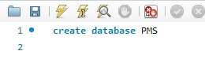

**Step:2**

Creating table ***Employee***:

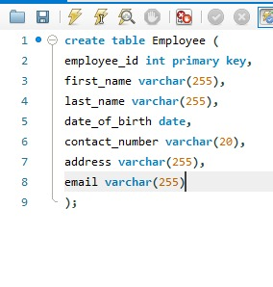

**Step:3**

Creating table ***Salary_Details :***

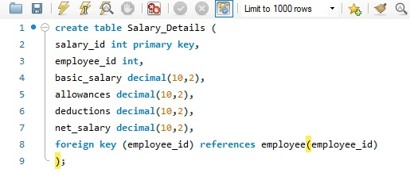

**Step:4**

Creating table ***Attendence :***

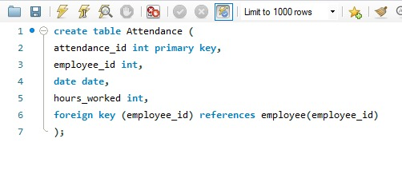

**Step:5**

Creating table ***Deductions:***

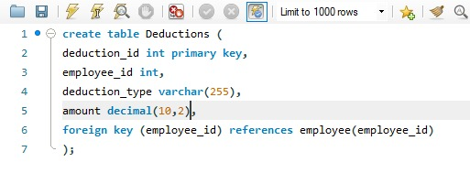

**Step:6**

Creating table ***Bonuses:***

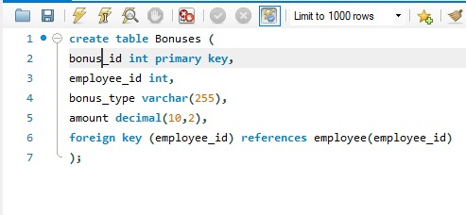

**Step:7**

Creating table ***Tax_details:***

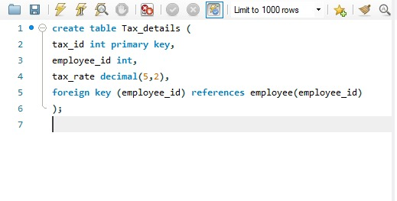

**Step:8**

Creating table ***Payroll_log:***

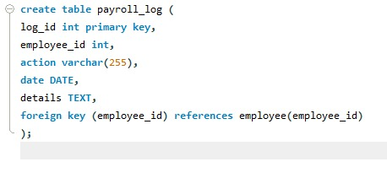

**Step:9**

Creating table ***Departments:***

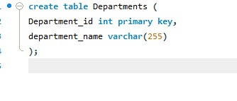

**Step:10**

Creating table **Designations:**

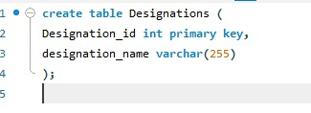

**Step:11**

Creating table ***users:***

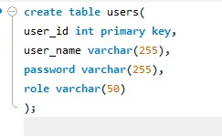

**Step:12**

Creating table *EmployeeLeave:*

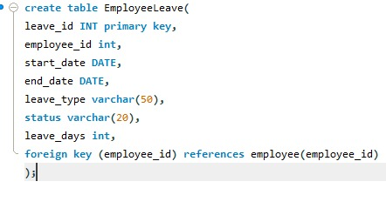

**Alteration:**

